Local Winery Liquidation Sale
I’m reaching out first to our Sierra Foothill wineries to offer some BIG savings on items you all use at prices you can’t beat. I know the timing sucks, but the Grim Reaper comes to take one away without regard for timing. If you haven’t heard that loveable rascal Charles B Mitchell passed on this summer. Long story short, Charles B Mitchell Vineyards will be liquidated starting today. I’ve compiled an incomplete list of winery items that may help you carry on through these uncharted difficult times in the wine industry.
Serious Inquiries only Please
Barrels
We’ve got hundreds – over 200 full of wines mostly from 2024 and 2023 vintage (a list of varietals and quantities upon request) minimum purchase ($300 - $500) as they come 2 barrels of wine per barrel rack $3-5 per gallon ( 59 gallon barrels but calculate price as 50 gallons) includes the barrels and each rack . Quantity purchases welcome – prices negotiable
100+ empty barrels sitting two on each wine rack, clean, gassed and ready for your wine storage minimum purchase 2 barrels on a rack $100, Quantity purchases welcome Price negotiable
some ready for a new life @ $25 possibly destined to be planters
others dry and looking for that creative furniture maker to do their magic. By the whole lot for a magical deal.
Bottles
Approximately 240 cases of 7126 AG - 750ml glass (screw top) @$7 per case in pallets of 70 cases Buy the whole lot and get as many screw cap closures as we have too. SOLD
Approximately 40 cases of 500 ml glass @$5 per case
Miscellaneous cases of various bottles
5 cases of 6-liter bottles for those special auction wines SOLD
Miscellaneous closures
Wine Yeasts and nutrients from Scott Labs - unopened and kept refrigerated - ask for our list
Filter sheets 40X40 SOLD
9+ boxes of 100-sheets @$200/ box various types from EK to 700. Take the whole lot for $1200
Oak Wood Chips
4 – 20 lb Moxon French Oak chips @ $100 each
1 – 40lb American Quercus Alba oak chips @ $175
Silicon Bungs @$2 each

Bottle Your Own Equipment
Get all set up for a most popular fun event for your wine customers. Charles B Mitchell’s most successful sales event ever!
3 – SS 6 bottle Fillers @ $1000 each OBO - TWO SOLD
1 – ABC Manufacturing of Canada SS pneumatic Corker $500 SOLD
1 – single corker stand up @$50
1 – SS ~50 gallon upright Bladder Press on its own stand (pretty cool for small batches)
Plus several white 50+ gallon plastic ‘garbage cans’ fermenters with lids, carboys…

SS Wine Transport Tanks ~330 gallon @$900 each SOLD
Wine 2-barrel steel racks @$25-50 each depending on condition
Wood Pallets
Lab Equipment & Supplies– Make an Appointment & take a look
Tasting Room, Guest House & Miscellaneous Items
Tasting room items including barrel stools, a stainless-steel wine tank bar, and collectible display pieces to add character and wine history to your space.
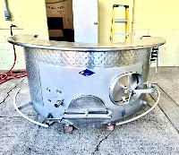
- Stainless steel tank bar – Custom-built, striking centerpiece for a tasting room or entertainment area. Constructed from a stainless steel fermenting tank. $5,000

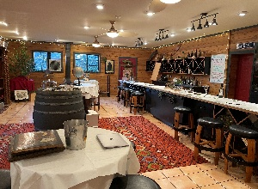
- Handcrafted Fair Play bar stools – Locally made, high-quality craftsmanship. $200 each OBO
- Antique display pieces – Armoires, cabinets, and other fine-quality display furniture. Excellent prices. These pieces genuinely elevate a space.
- Puncheons (imported from France) – 2 available. $225 each
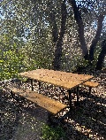
- Picnic tables – Several available. $130–$230 each

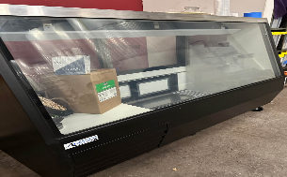
Deli case (excellent condition) – New-ish. $750

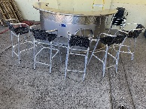
- Outdoor bar stools – $50 each

Guest House Contents
We are also liquidating a guest house, including:
- Bedroom furniture
- Wall hangings and mirrors
- Window air-conditioning units
- High-end, large-capacity refrigerator and freezer
- High-end washer and dryer set
- A variety of miscellaneous household items
Quality pieces at excellent prices. Contact Jill for photos, details, and availability.
If you’re interested in motorcycles, motorcycle equipment, or a cruiser boat, contact Jill for more information.

Contact: Jill Mitchell 530-282-5656 leave detailed message

