sacramento home winemakers

The Grapevine

newsletter -- July 2018
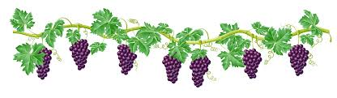

JULY 18 Program
Sustainable and Organic Vineyards

Join your fellow Home Winemakers on Wednesday, July 18th at 7pm for our Monthly Program upstairs at the Turn Verein located at 3349 J Street in Sacramento. There is additional parking in the back.

This month’s program is devoted to the vineyard. Joaquin Fraga is a Viticulture Consultant MS. Joaquin’s focus is on Sustainable and Organic Emphasis in the vineyard. He is a graduate from Davis and is currently managing a vineyard in Davis, Ca.

I joined Joaquin in June for a vineyard walk and I liked what I saw, he has used no pesticides in the last three years and the vineyards were well maintained.

Please join us for an educational evening pertaining to the vineyard. I plan on purchasing Syrah grapes from the vineyard. Zinfandel and Malbec are also grown. If you haven’t signed up for any grapes yet this might be an opportunity to do so.

Bring a bottle of wine to share at the meeting if you wish to do so and don’t forget your glass.

As always help in setting up and cleaning up at the meeting is always appreciated.

Please consume responsibility.

Contact Vice President Terry Piazza-Perham if you have program questions.
piazza-perham@att.net

-- Vice President Terry Piazza-Perham

PRESIDENT’S MESSAGE

A BIG thank you to John Troiano for being our wine evaluator at the June meeting. And to our members who brought in their wine to share with us and who were open to hear the good and bad about it. The ability to be open to criticism is a trait that winemakers seem to possess. We know that all of the wines we make won’t be best of shows, but we keep striving and learning to do our best and produce some excellent wines. Learning new things to improve is always helpful. And a shout out to our cellar crew that night who materialized out of nowhere to help with the staging, organizing and pouring of the wines. Solid team effort.

(continued on next page)
If you haven’t already secured your grapes for 2018, this needs to be your priority. To see what SHW group buys are available, go to our website (www.sachomewine.org) and on the home page, click on “2018 Grapes: For Sale, Group Buys” in the far-right column. There are group buy opportunities still available. In addition, in that same section, you will find a listing of known grape growers who are selling. Scott Harvey is once again offering grape must of Sangiovese, Syrah, and Barbera at $1.00 per pound (must, not grapes).

Do you have a friend or relative who raves about your home wine? Tell them about the 2018 Home Winemaking 101 class to be offered by the club on July 28 in Granite Bay. Contact Gin Yang at ginyangstaehlin@yahoo.com.

We still need volunteers to staff the home winemaking booth at this year’s State Fair which runs from July 13-29. On the club website, click on “Blog” on the far right, if you don’t see the Booth blog, scroll down till you locate the link. The sign-up page is simple; just click on the sign-up page link and you can select your shift(s). State fair admission and parking credentials provided.

The Club is still looking for an equipment manager. We have a storage area for the equipment, we just need a coordinator to oversee the rental of it. As we get closer to harvest, there is going to be a need for the equipment and unless there is a coordinator in place, it’s going to be difficult to have it available. Please consider what you might be able to do. A coordinator with several members who can assist would be ideal to spread out the responsibility and provide accessibility when needed.

We are already more than halfway through 2018 and when I reflect back on what the Club has done this year, I’m amazed. A number of our events occur annually, like the Jubilee and Competition and the State Fair competition. This year was no different and each of those events was a HUGE success. Our general meetings have provided excellent speakers and evaluations with great participation from the membership. The meetings are well attended, and our March evaluation program was a new and engaging learning program. As we come into the final stretch of 2018, it’s going to be HOT, as always in Sacramento, but you can count on SHW providing quality education and wine making info to improve your skills. So, don’t forget to volunteer, be sure to come to the meetings and participate in YOUR Club!

Hope to see you soon.

Cheers!

-- President Joe McGillivray

iN THIS ISSUE… | Page |  | Page
July 18 Monthly Program | 1 | Winemaking 101 Workshop | 4
President’s Message | 1-2 | Crush T-Shirts – Order By July 31 | 5
Volunteers and Supporters | 3 | Fruit Wine Making Workshop Recap | 5
Volunteer for State Fair Home WM Booth | 3 | Events Calendar | 6
June 20 Meeting Recap | 3

THANK YOU VOLUNTEERS AND SUPPORTERS!

Lots of volunteers help keep SHW running smoothly! Thank you for stepping up!
June’s meeting appreciation:

- John Troiano for objectively evaluating members’ red non-Bordeaux grape wines.
- Members who brought in their wines for evaluation: Marcus and Jenny Meadows-Smith, Jose and Alison Orozco, Judy Pinegar, Scott Elliott, Mark Davis, Christa Ring, Shannon Shackelford, and Marco Sguazzin.
- Jerry Roark for managing the cellar at the meeting assisted by Robert Wharton and Mike Menard.
- Hospitality: Craig and Jacque Brown for the cheese and bread. For set-up and clean-up: Vickie Alvarez, Jamie Kojak (always there early to help!), Jerry Roark, and Olga Lukin.
- Bruce Currie for his expertise at the monthly wine troubleshooting table.

Thank you for volunteering to support SHW outside our monthly meetings!
- Krista and Jerry Roark for hosting June’s executive board meeting.
- Judy Pinegar for hosting and teaching the June 30 Fruit Winemaking workshop.

2018 California State Fair Home Winemaking Booth – Volunteer!
As with past years, SHW will be staffing a booth during this year’s run of the California State Fair…July 13-29. Each day offers three opportunities (time slots) to volunteer. Those who volunteer will receive a complimentary parking pass and fair ticket. Plan to arrive early or stay late to experience the sights, sounds and smells of the State Fair the day of your shift.

The State Fair has made the completion of the Megan’s Law Form much easier by moving it to an on-line form accessible via the web. When you sign up for a shift, you will be sent the Megan’s Law Form link and will be contacted by SHW member Fred Millar to make arrangements to get you the parking pass and fair ticket. If possible, please sign-up early so that Fred can mail you the pass and ticket via the US Postal Service (easier) versus having to drive somewhere to meet you (much more time consuming!). Visit the sign-up page at www.SignUpGenius.com/go/30E0F49ABAA23A2F94-volunteers1.

Questions? Contact Robert Wharton at robert.wharton @hpe.com (his contact info is also on the sign-up page).

June 20 Meeting Recap
The meetings guest evaluator, John Troiano (pictured on right)tasted and gave feedback on nine members’ wines. Thanks to John for his wisdom, members’ for remembering how they made the wine and bringing in the wines for eval.

Winemaking 101 – Saturday, July 28, 2018
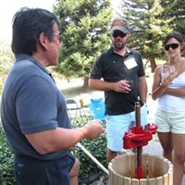
If you have been wanting to learn to make wine or to brush up on your basic winemaking skills, join us at SHW’s Winemaking 101.

The 5-hour workshop is planned for Saturday, July 28 starting at 9AM at the home winery of Kathy and Ron Loder in Granite Bay. Part lecture, part demonstration – learn the basic steps for making dry red and white wines and the use of winemaking equipment.

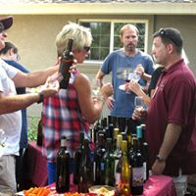
You’ll learn wine making terminology and about the resources you’ll need to get started – supplies, small equipment, grapes, mentors. There will also be Winemaking Chemistry Basics (no worries!). Experienced winemakers will be present to answer your questions.

The workshop concludes with a potluck and wine tasting where you’ll get time to mingle with fellow winemakers. Ron Loder also offers you a tour of his home vineyard.

WM 101 also has an Equipment Certification component for SHW members to complete before being eligible to rent SHW’s larger pieces of winemaking equipment – destemmer-crusher, basket presses and filter.

WM 101 also prepares attendees to participate in the members only Beginning Winemakers Group – a mentored group crush and with wine making guidance. More on that at workshop.

Space is limited. Winemaking 101 workshop is free for current SHW members; $30 per person for non-members. Non-members can apply their workshop fee to 2018 membership if joining SHW on workshop day. Details with location address to follow after confirming registration.

SHW Members: if you’re a current SHW member, email Gin and let her know how many are in your party. Non-members: contact Gin and also mail form below.

Gin Yang contact info: email - ginyangstaehlin@yahoo.com or text/call 916 217-0294.

------------------------------------------------- Cut Here ---------------------------------------------
Please register me (us) for SHW’s Winemaking 101 - Saturday, July 28, 2018

Name (s) ___________________________________________________________________

Email Address AND Phone ____________________________________________________

___ Register me for WM 101. I am not a current member and would like to join SHW. (Mail with membership form found at www.sachomewine.com.)

___ I am not a member and enclosed is the Winemaking 101 workshop fee of $30 per person.

Mail to: SHW Treasurer Bob Peake || P O Box 691 || Folsom CA 95763

2018 SHW Crush T-Shirts – Order by July 31
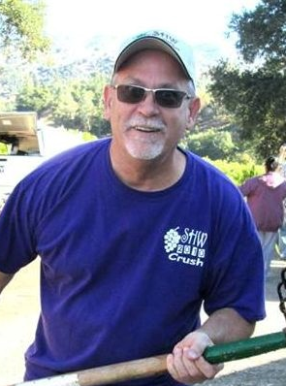
You’ve seen members wear these crush T-shirts at meetings, crushes, and around town. Get one for you and some for your crush crew so that they don’t have to sacrifice one of their fave old shirts to help you make wine.

For a limited time only, 2018 SHW Crush T-shirts are available by order. See more details and photos on the SHW website: http://www.sachomewine.com/2018-shw-crush-t-shirts-order-yours.

FRUIT Winemaking WORKSHOP
Thanks to SHW member Judy Pinegar for hosting SHW’s Fruit Winemaking Workshop on a very warm June 30 Saturday! Photos by John O’Dell.

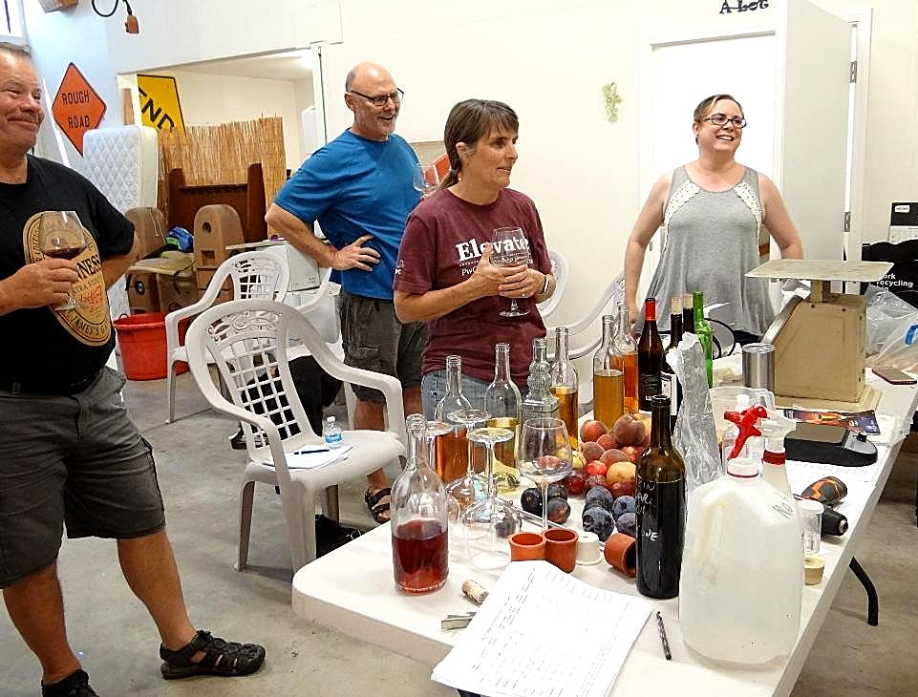
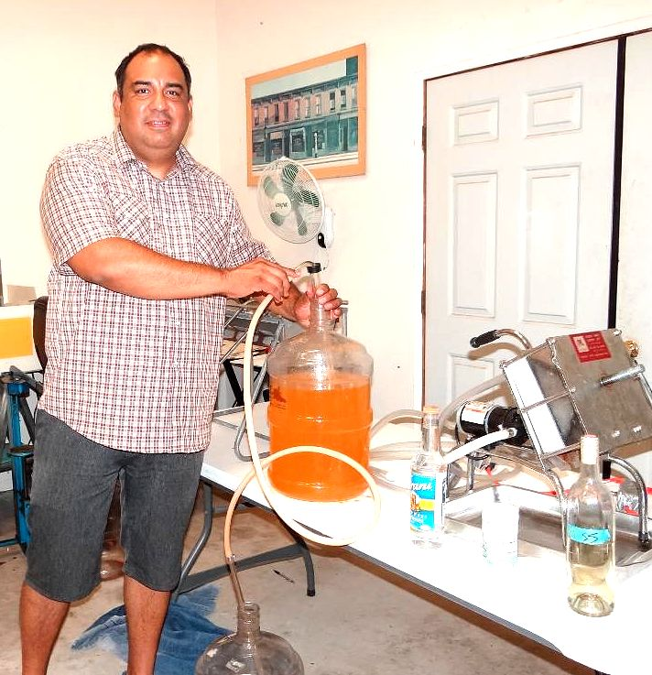

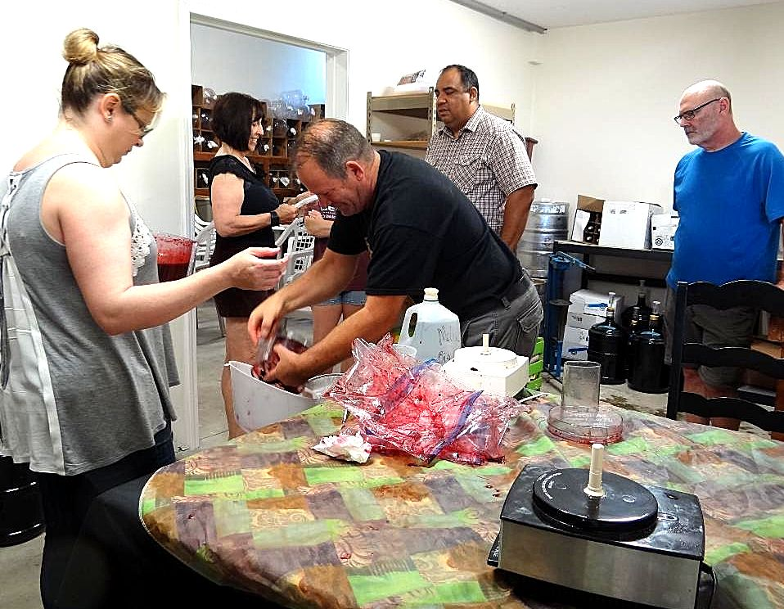

SHW Events Calendar
- Executive Board Meetings –6:30 PM start; contact Prez Joe McGillivray for location; pyramidlake59@gmail.com.
- General Meetings –7:00 PM start; upstairs at 3349 J Street, Sacramento (unless noted)
- More calendar and details - www.sachomewine.com; see Events Calendar and Newsletters.

General Meeting | July 18, 7 PM  Wednesday | Sustainable Vineyards  Guest Speaker: Joaquin Fraga
Winemaking 101 | July 28, 9:30 AM  Saturday | Beginning Wine Making Workshop  Location: Granite Bay
General Meeting | August 15, 7 PM  Wednesday | Native and Ambient Fermentation  Guest Speaker: Ryan Sherman, Fields Family Wines
General Meeting | Sept 19, 7 PM  Wednesday | Taste the Gold!  Members: bring in your top winners for tasting
General Meeting | October 17, ? PM  Wednesday | Harvest Dinner

From:
Sacramento Home Winemakers
P O Box 691
Folsom CA 95763

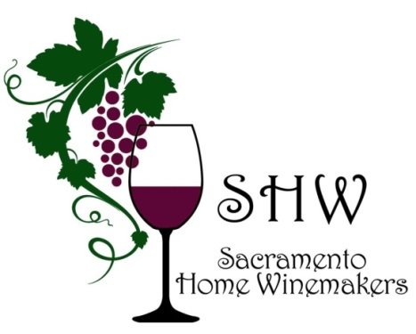
www.sachomewine.com
Find us on facebook!

To:

